Debt Management Strategy Assessment: Evaluating Cost and Risk Indicators Against Implementation Outcomes in Kenya

Abbreviations and Acronyms
ATM Average Time to Maturity
ATR Average Time to Refixing
BPS Budget Policy Statement
DMS Debt Management Strategy
FX Foreign Exchange
GDP Gross Domestic Product
IMF International Monetary Fund
Ksh Kenya Shilling
MTDS Medium Term Debt Management Strategy
PDMO Public Debt Management Office
PFM Public Finance Management
SDR Special Drawing Rights
USD United States Dollar

Contents
Abbreviations and Acronyms 2
1. Introduction to Debt Management Strategy Assessment 4
2. Overview and Evolution of Public Debt 5
3. Cost Indicators Assessment against Strategy Targets 9
4. Risk Indicators Assessment against Strategy Targets 12
5. Debt Management Strategy Borrowing Targets against Actual Outcomes 19
6. Findings, Conclusions and Policy Recommendations 20

Executive Summary
This paper evaluates the effectiveness of Kenya’s Medium-Term Debt Management Strategy (MTDS) over the period 2016–2025 by comparing strategy targets with actual outcomes across key cost, risk, and borrowing indicators. It finds that while the debt management framework is well developed and consistently implemented in form, significant gaps persist between planned targets and realized outcomes, largely due to evolving market conditions and implementation constraints.
Public debt increased substantially over the period, accompanied by a structural shift toward domestic borrowing, reflecting efforts to reduce foreign exchange risk but also increasing reliance on domestic markets.
Cost indicators, particularly interest payments, consistently exceeded targets due to rising debt levels, higher domestic borrowing costs, and global financial tightening, despite relatively close alignment in implied interest rates.
Risk indicators show mixed results, with some progress in extending maturity in earlier years but persistent shortfalls in external Average Time to Maturity (ATM), Average Time to Refixing (ATR), and fixed-rate debt, driven by limited access to long-term financing, rising interest rates, and increasing reliance on shorter-term and floating rate instruments.
Borrowing outcomes reveal a clear structural break after 2019, as constrained access to external financing and exchange rate pressures led to a shift toward domestic borrowing, resulting in persistent deviations from targets.
Overall, the findings highlight that while the MTDS provides a strong strategic framework, its effectiveness is shaped by external financing conditions, market realities, and the need for more adaptive and realistic implementation approaches.

Introduction to Debt Management Strategy Assessment

- Public debt management is the process of establishing and executing a strategy for managing government debt to raise the required amount of funding, achieve cost and risk objectives, and meet any other sovereign debt management goals that the government may have set. Many governments including the Kenyan government borrow to finance infrastructure, cover budget shortfalls, or respond to crises and these results to creation of obligations that must be serviced and repaid.

- The Public Finance Management (PFM) Act Cap. 412A, section 62, establishes the Public Debt Management Office (PDMO). The objectives of PDMO are to: minimise the cost of public debt management and borrowing over the long-term taking account of risk; promote the development of the market institutions for Government debt securities; and ensure the sharing of the benefits and costs of public debt between the current and future generations.

- In section 63 of the PFM Act, Cap 412A, highlights the functions of PDMO, of which one is to prepare and update the annual medium-term debt management strategy. The Debt Management Strategy (DMS) is a medium-term government plan which covers three to five years, and it sets out how the government intends to achieve a desired composition of public debt portfolio.

- In Kenya, Medium-Term Debt Management Strategy (MTDS) has been prepared annually for the last 17 years, in accordance with Section 33 (3) of the PFM Act, Cap. 412A and is anchored on the macroeconomic assumptions outlined in the Budget Policy Statement (BPS). This reflects good transparency and technical capacity. However, implementation of the strategies has been a challenge.

- Therefore, the main objective of this assessment of published Kenya’s debt management strategies will be to evaluate their effectiveness and identify gaps between the prescribed framework and actual implementation, thereby informing corrective actions. Specifically, the assessment aims to: (i) analyze the evolution of Kenya's public debt portfolio over 2015-2025, including its growth and composition; (ii) evaluate cost management performance by comparing realized cost indicators against DMS targets, assessing deviations, and identifying the drivers of cost overruns; (iii) assess risk management performance by benchmarking key risk indicators -refinancing, interest rate, and exchange rate risks- against DMS targets; and (iv) conduct a detailed implementation review by comparing actual borrowing outcomes with those envisaged in the DMS.

- Target audience: The target audience are the policymakers in the National Treasury, Parliament, and development partner institutions who need evidence-based account of what has worked, what has not and why, in the Kenya's debt management strategy formulation and implementation. Practitioners from other countries could also benefit from that.

- Scope of the assessment: Assessment covers Kenya's central government debt portfolio over the period of July 2015 to June 2025. Domestic debt encompasses all government securities (Treasury bills and bonds) issued in Kenyan shillings in the domestic market while external debt encompasses all borrowing by the national government from foreign creditors, denominated in foreign currencies. The analysis excludes the guaranteed debt, Central Bank Overdraft, IMF Special Drawing Rights (SDR) Allocation and Bank Advances by commercial banks.

- The paper is organized as follows: Section 2 outlines the overview and evolution of Kenya’s public debt. Section 3 outlines the cost indicators assessment against strategy targets. Section 4 highlights the risk indicators assessment against strategy targets. Section 5 highlights the DMS borrowing targets against actual outcomes and Section 6 shows findings, conclusion and policy recommendations.

Overview and Evolution of Public Debt
- Public debt: Public debt according to Article 214 (2) of the Constitution of Kenya 2010, means all financial obligations attendant to loans raised or guaranteed and securities issued or guaranteed by the national government.

- Public debt growth: Total public debt has risen sharply and consistently over the period, growing from Ksh 3,611 billion in June 2016 to Ksh 11,814 billion in June 2025 as shown in Figure 1. The growth is because of sustained expansion in debt issuances and disbursements, driven by government growing needs over the period characterized by fiscal deficits. In addition, there was a depreciation of the domestic currency, which has contributed to increase in the value of the external debt stock in local currency terms. For instance, between end 2015 and end June 2025, the Kenyan shilling depreciated by 26.3 percent against the US dollar, moving from Ksh 102.31 to Ksh 129.23 per dollar.

Figure 1: Evolution of Public Debt
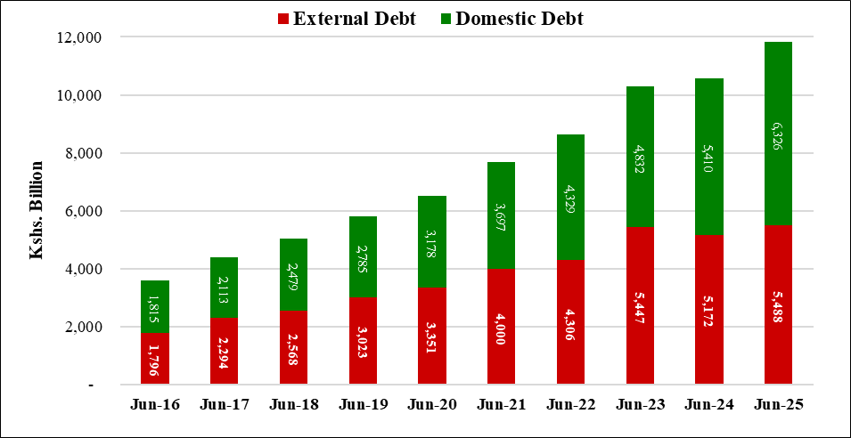
Source: Various Annual Reports

- Public debt composition: While the debt was nearly evenly split between external and domestic sources in 2016, domestic debt grew more aggressively and became the dominant component by June 2025 as shown in Figure 2.

Figure 2: Public Debt Composition
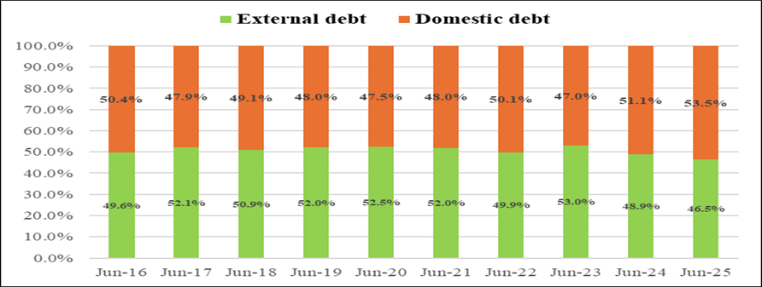
Source: Various Annual Reports

- This shift reflects, in part, a deliberate strategy to reduce exchange rate risk from foreign currency borrowing, as evidenced by the decline in Foreign Exchange (FX) debt as a share of total debt from 50.7 percent in June 2016 to 47 percent by June 2025 (Figure 21). It equally signals the progressive development and deepening of the domestic debt market, which has increasingly served as a reliable and accessible source of financing for government expenditure needs. As shown in Figure 3, gross domestic borrowing has increased from 39 percent in June 2016 to 82 percent in June 2025.

Figure 3: Evolution of Gross Domestic Borrowing
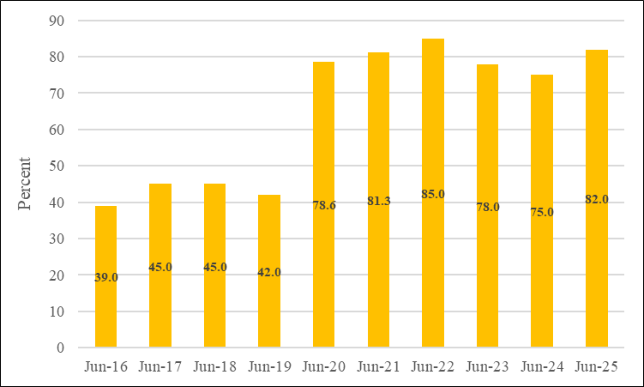
Source: Various Annual Reports

- Public external debt composition: The external debt portfolio has undergone a significant structural shift over the decade. Bilateral debt and market-based instruments (Eurobonds and commercial debt combined) have declined from their respective peaks. On the other hand, multilateral debt has risen from 44 percent in 2016 to 55 percent in 2025, indicating sustained confidence and support from international institutions (Figure 4).

Figure 4: Public External Debt Composition
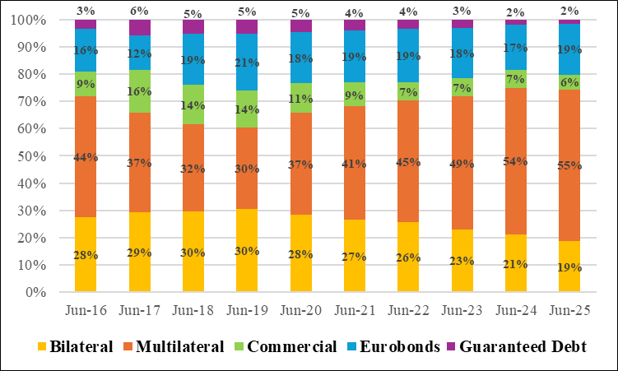
Source: Various Annual Reports

- Public domestic debt composition: The domestic debt portfolio reflects a clear maturity extension strategy, with Treasury bonds rising sharply from 63 percent in June 2016 to a peak of 86 percent in June 2024, while Treasury bills declined from 35 percent to just 11 percent over the same period. This deliberate shift from short-term to long-term instruments significantly reduces refinancing risk. Pre-1997 debt has been nearly fully phased out, and other domestic debt remains a minor component throughout the period.
Figure 5: Public Domestic Debt Composition
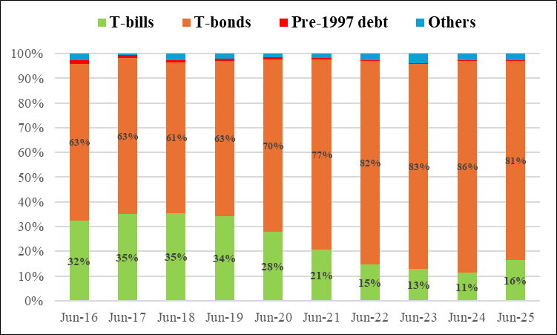
Source: Various Annual Reports

- Public debt to Gross Domestic Product (GDP): Public debt to GDP ratio rose from 47.6 percent in 2016 to a peak of 72.0 percent in June 2023 (Figure 6), signaling that debt was growing far faster than the economy (Figure 7). In 2024, it eased to 66.9 percent before edging up marginally to 67.8 percent in June 2025. This declining ratio, despite rising absolute debt levels, points to stronger GDP growth and fiscal consolidation efforts aimed at improving debt sustainability.

Figure 6: Evolution of Public Debt to GDP
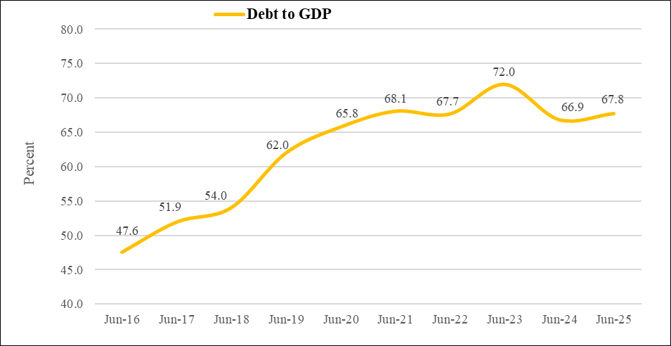
Source: Various Annual Reports

Figure 7: Evolution of Debt and GDP Growth Rates
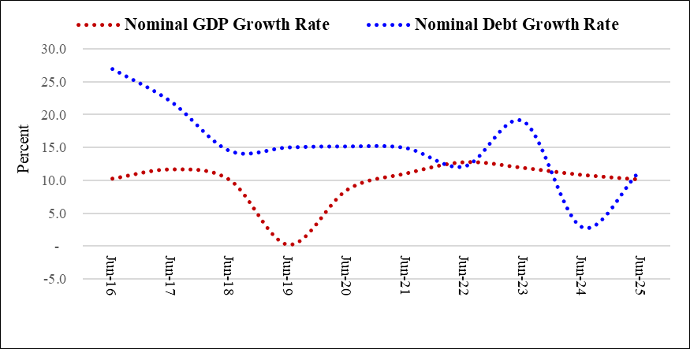
Source: Various Annual Reports

Cost Indicators Assessment against Strategy Targets
- Cost indicators: Two indicators were selected to show the cost of the debt trajectory overtime, against strategic targets: (i) Interest payments as a share of GDP; (ii) Implied Interest Rate.

- Interest payments as a share of GDP: As shown in figure 8, interest payments as a percentage of GDP rose steadily from 3.7 to 5.9 percent over the 10-year period, consistently exceeding DMS targets in 9 out of 10 years. It is important to note that while this indicator is useful for assessment, it is largely beyond the direct control of the PDMO, as it is driven by market developments in interest rates.

Figure 8: Interest rate as a percentage of GDP Target against Outturn (2015-2024 DMS)

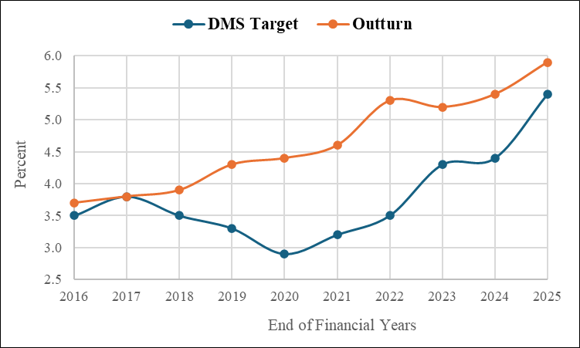
Source: Various MTDSs
- The rising payments of about 6 percent of GDP is because of rapid growth of debt stock over the period. As the total debt stock expanded from Ksh 3,611 billion in June 2016 to Ksh 11,814 billion by June 2025 (Figure 1) due debt issuances and disbursements, interest obligations increased commensurately (Figure 9). Additionally, the shift in debt composition toward domestic debt (Figure 2) and, within it, toward Treasury bonds which carry higher interest rates (13.5 percent on average) than short-term securities (11 percent on average) (Figure 5), further pushed interest payments above target.

Figure 9: Evolution of Total Interest Payments
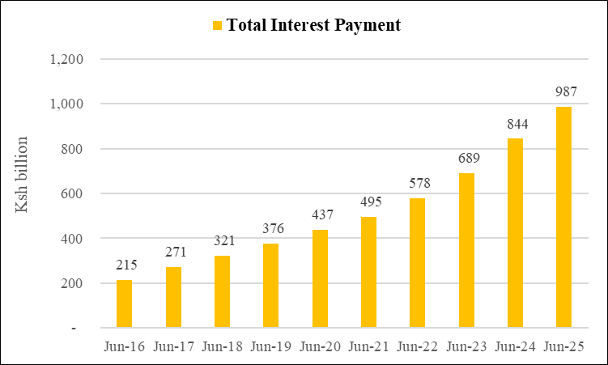
Source: Various Annual Reports

- The standard deviation of 0.6 percentage points indicates that, on average, the actual debt metric deviated from the target by less than one percentage point. This indicates that deviations in interest costs are stable over time, while the consistently positive gap shows that actual interest payments systematically exceed targets, reflecting optimistic forecasting assumptions that underestimate borrowing costs.

- Implied interest rate: Over the 10-year period, the implied interest rate outturn moved broadly in line with the DMS target, with close alignment in 2016 to 2017 and a brief convergence in 2023 (Figure 10). From 2018 to 2022, actual borrowing costs consistently exceeded the target by up to 120 basis points before closing with a reversal in 2025, where the target (9.8 percent) overshot the outturn (8.8 percent), showing a conservative strategic buffer against rising rates.

Figure 10: Implied Interest Rate Target against Outturn (2015-2024 DMS)
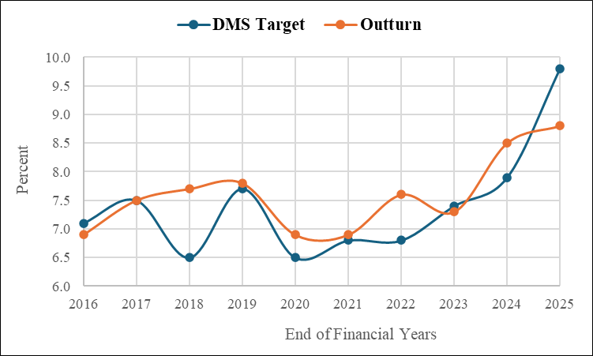
Source: Various MTDSs

- Borrowing costs exceeded targets between 2018 and 2022 due to market pressures that pushed domestic and external yields above assumed levels. Additionally, shifts in investor risk appetite particularly in the context of tightening global financial conditions and widening sovereign spreads due to credit rating downgrade as shown in Table 1, further elevated the cost of new borrowing beyond projected benchmarks.

Table 1: Kenya’s Credit Ratings by Fitch
Date | Rating | Outlook
Feb 09 2018 | B+ | Stable
Jun 19 2020 | B+ | Negative
Dec 14 2022 | B | Stable
July 20 2023 | B | Negative
August 9 2024 | B- | Stable
July 25 2025 | B- | Stable
Source: Various Fitch Reports

- The standard deviation of 0.6 percentage points reflects modest but consistent deviations driven largely by market pressures and tightening global financial conditions. This indicates a reasonable degree of alignment between planned and actual borrowing costs, with no fundamental departure from the debt management strategy's interest rate benchmarks.

Risk Indicators Assessment against Strategy Targets
- Risk Indicators: In this analysis, selected risk indicators are assessed against their respective DMS targets.

- Debt maturing in 1 year as percent of total debt: The share of debt maturing within one year deviated significantly above DMS targets between 2016 and 2017, peaking at 27.4 percent against a target of 15.6 percent in 2017 (Figure 11). The deviation reflected investor preference for short-term instruments amid rising Central Bank rates over the same period (Figure 12), as investors anticipated further rate increases, making long-term commitments less attractive.

Figure 11: Debt Maturing in 1 year as a percentage of Total Debt Target against Outturn (2015-2024 DMS)
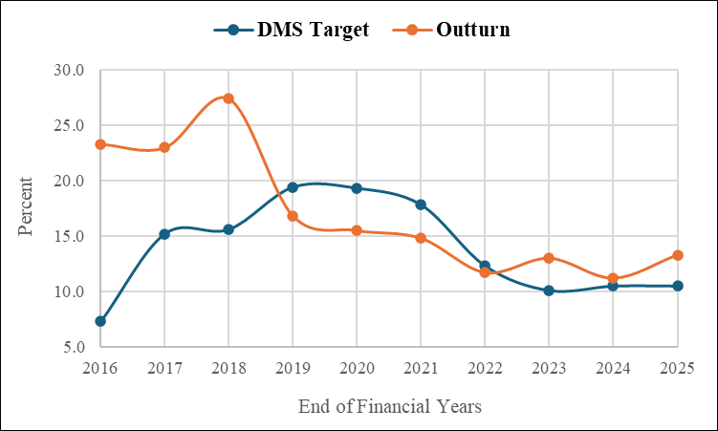
Source: Various MTDSs

Figure 12: Movement of Central Bank Rate (2015-2025)
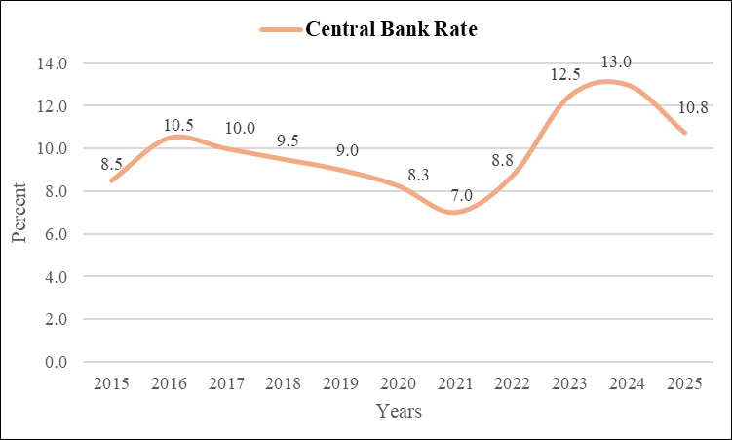
Source: Central Bank of Kenya

- A correction followed from 2018 to 2021, with actual outturn falling consistently below DMS targets, reflecting a deliberate shift toward medium and long-term instruments to extend the portfolio's maturity profile (Figure 13). A slight uptick in 2023 and 2025 signals emerging pressure on the short end of the portfolio, driven by elevated Central Bank rates exceeding 10 percent over the same period (Figure 12), which led investors to favor short-term instruments in anticipation of persistently high rates.

Figure 13: Domestic Debt Securities by Maturity Profile
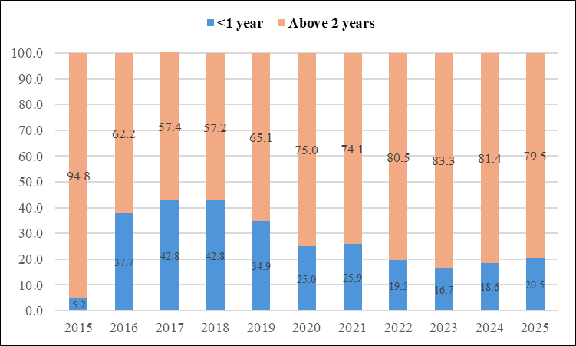
Source: Various MTDSs

- External debt Average Time to Maturity: Throughout the review period, the external debt ATM consistently fell short of DMS targets, with the shortfall widening from an initial gap of 4.1 years in 2016 to the most pronounced divergence of 4.8 years in 2023. In 2025, a notable convergence was achieved, with outturn reaching 10 years against a target of 10.3 years (Figure 14).

Figure 14: External Debt Average Time to Maturity Target against Outturn (2015-2024 DMS)
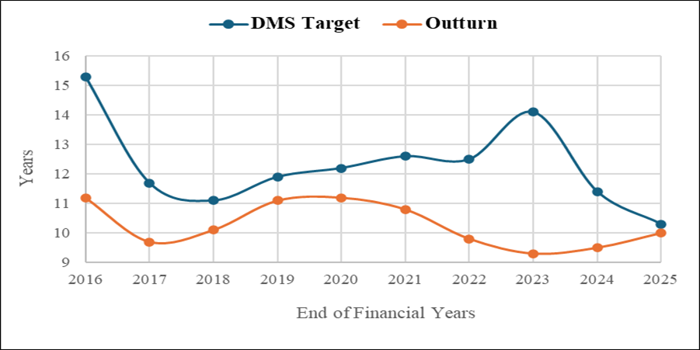
Source: Various MTDSs
- The consistent inability to reach ATM targets over the review period is attributable to structural constraints in accessing long-term concessional financing and increased reliance on shorter-term commercial borrowing. Between 2016 and 2019, as shown in Figure 15, the share of commercial debt with shorter maturities, including syndicated loans and Eurobonds increased, while multilateral debt declined. In addition, especially after 2021 onward, tightening of global financial conditions characterized by rising global interest rates and tightening liquidity, led investors to begin shortening duration, hence forcing a shorter maturity structure than planned.

Figure 15: Outstanding Public External Debt Composition
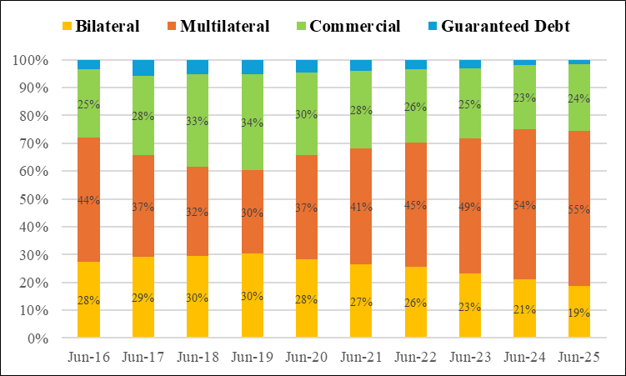Source: Various Annual Reports

- The relatively low standard deviation (1.4 years) indicates that deviations in external ATM are not highly volatile but rather consistently below target, pointing to persistent structural constraints in achieving longer maturities rather than random year-to-year shocks.

- Domestic debt Average Time to Maturity (ATM): The review period commenced with a significant shortfall, with the actual outturn of 4.3 years falling well below the DMS target of 7.8 years. A reversal occurred in 2017 to 2021, where the outturn exceeded the DMS targets, reflecting a period increased issuance of Treasury bonds and shift away from short term Treasury bills as shown in Figure 5. The DMS target rose aggressively to a peak of 9.1 years in 2022 while the outturn gradually declined to 6.4 years by 2025 (Figure 16).

Figure 16: Domestic Debt Average Time to Maturity Target against Outturn (2015-2024 DMS)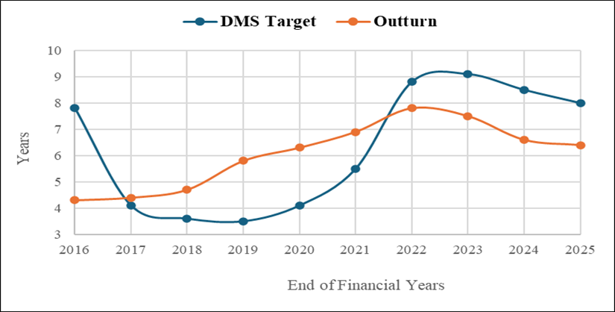
Source: Various MTDSs

- The steep yield curve as shown by Figure 17 is characterized by significantly higher long-term interest rates relative to short-term rates making long-term domestic borrowing costly. This leads to a shift toward shorter maturities and results in a decline in ATM well below the target between 2022 and 2025.

Figure 17: Government Securities Yield Curve
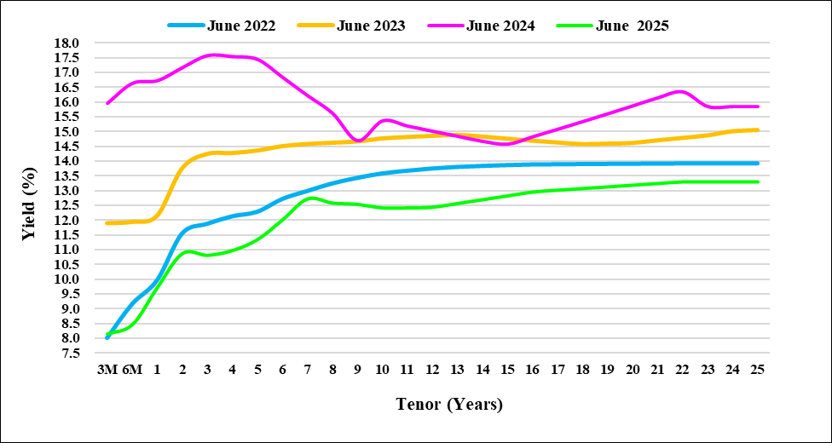
Source: Nairobi Stock Exchange

- The relatively high standard deviation (1.87 years) indicates that deviations in domestic ATM vary significantly over time, reflecting changing market conditions and shifts in borrowing strategy rather than a consistent pattern.
- Average Time to Refixing: The review period commenced with the most significant deviation of 4.6 years, reflecting a portfolio heavily weighted toward short-term and floating-rate instruments, before narrowing by 2018 as targets were revised downward to better reflect portfolio realities. 2019 marked the sole point of convergence, with outturn marginally exceeding the target at 8.1 years against 8.0 years (Figure 18). From 2020 onward, divergence widened progressively, peaking in 2023 where the outturn fell 3.7 years short of the target, sustaining elevated exposure to interest rate risk through the remainder of the review period.

Figure 18: Average Time to Refixing Target against Outturn (2015-2024 DMS)
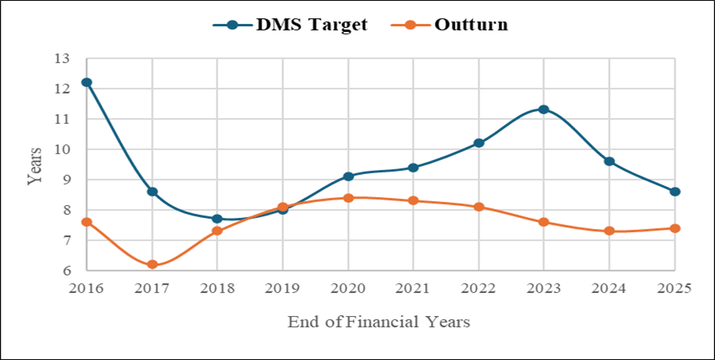Source: Various MTDSs
- The increase in floating rate and shorter-term debt since 2019, alongside a decline in fixed rate dominance, has raised the frequency of interest rate refixing, contributing to the decline in ATR and its persistent shortfall relative to targets (Figure 19).

Figure 19: Movement of Debt by Interest Rate Type (2015-2024 DMS)
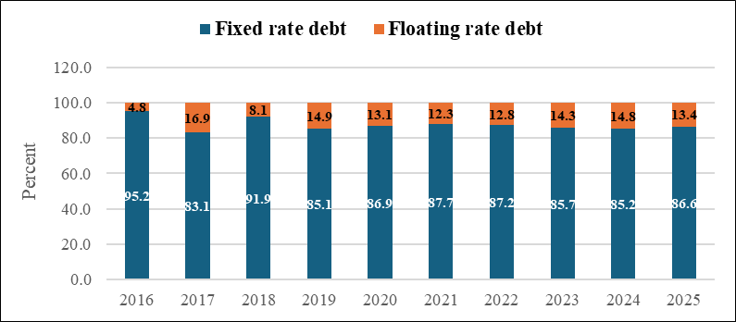Source: Various MTDSs
- The moderate standard deviation (1.4 years) indicates that deviations in ATR are relatively stable over time, while the consistently negative gap shows a persistent shortfall driven by underlying factors rather than short-term volatility.

- Fixed rate debt as a percent of total debt: The initial phase was characterized by high ambition and significant volatility, with the strategy commencing at a 100 percent fixed rate target. The widest deviation occurred in 2017 where the outturn dropped sharply to 83.1 percent against a target of 96.3 percent, and 2018 marked the sole point of convergence before slipping again to 85.1 percent in 2019. From 2020 onward, the outturn stabilized within a narrow band of 85.2 to 87.7 percent. However, DMS targets continued to fluctuate significantly maintaining a persistent gap of approximately 4 to 6 percentage points throughout the remainder of the review period (Figure 20).

- Consistent failure to meet fixed rate debt targets is attributable to rising cost of fixed rate borrowing, especially from 2021 onward amid global monetary tightening which made floating rate alternatives comparatively attractive from a cost perspective, leading the government to accept variable rate terms to manage overall borrowing costs.

Figure 20: Fixed Rate Debt as a percentage of Total Debt Target against Outturn (2015-2024 DMS)
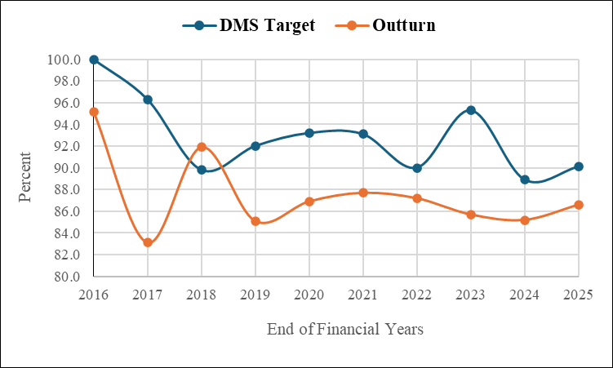
Source: Various MTDSs

- The relatively high standard deviation (3.9 percentage points) shows that the gap between target and outturn for fixed rate debt varies across years. The consistently negative gap indicates a persistent shortfall driven by changing market conditions and borrowing choices.
- Foreign exchange debt as percent of total debt: From 2016 to 2022, the outturn consistently fell below DMS targets with the largest deviation of 13.5 percentage points recorded in 2018. From 2022 onward a reversal occurred, with the outturn exceeding the target in 2023 and 2025 by up to 4.4 percentage points (Figure 21).

Figure 21: Foreign Exchange Debt as a percentage of Total Debt Target against Outturn (2015-2024 DMS)
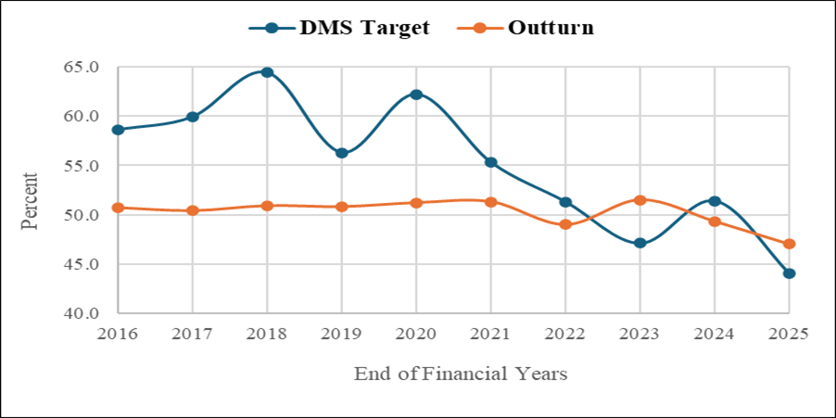Source: Various MTDSs

- The FX debt share remained below target in the early years because external borrowing did not increase as planned, limiting the buildup of foreign currency debt relative to total debt as shown in Figure 19. In addition, as shown in Figure 22, the sharp depreciation of the exchange rate particularly from 2022 onward increased the local currency value of external debt, offsetting reduced external borrowing and contributing to the persistence of FX debt above target.

Figure 22: Movement of United State Dollar to Kenya Shilling
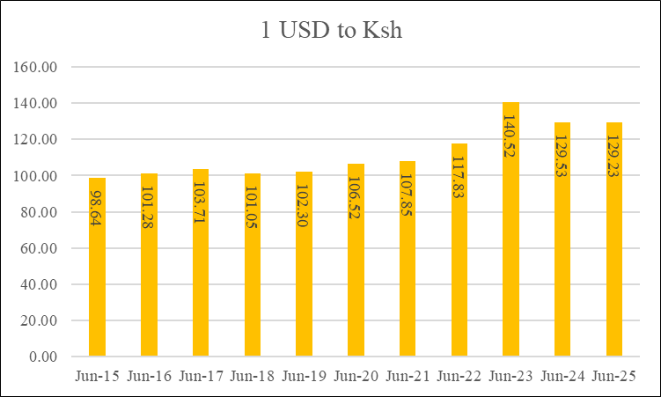Source: Central Bank of Kenya
- The high standard deviation (5.5 percentage points) reflects large changes in the gap between target and outturn over time, driven mainly by shifting targets, while the relatively stable outturn indicates limited flexibility in adjusting the share of foreign debt.

Debt Management Strategy Borrowing Targets against Actual Outcomes
- External gross borrowing: External gross borrowing was elevated between 2016 and 2019, with the outturn exceeding the target by 16 percentage points in 2016 before converging closely in 2019 at 57 to 58 percent. From 2020 onward, a sharp and sustained decline ensued, with outturn consistently falling below DMS targets, most notably in 2022 where the outturn of 15 percent fell 12 percentage points below, before both metrics settled at their lowest levels of 25 and 18 percent respectively in 2025 (Figure 23).

- The deviation in external gross borrowing reflects tighter global financial conditions, limited market access, and exchange rate pressures, which constrained external financing and led to a shift toward domestic borrowing, resulting in consistently lower external borrowing than targeted.

Figure 23: External Gross Borrowing Target against Outturn (2015-2024 DMS)
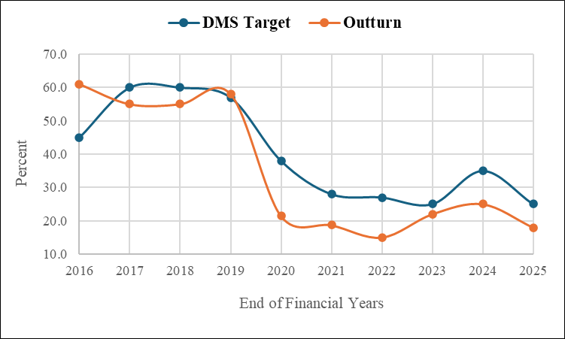
Source: Various MTDSs

- The high standard deviation (8.4 percentage points) indicates that deviations in external gross borrowing vary significantly over time, reflecting both a structural break after 2019 and strong sensitivity to changing global financial conditions.

- Domestic gross borrowing: From 2016 to 2019, domestic borrowing was relatively contained, with the closest alignment recorded in 2019 at 42 to 43 percent. From 2020 onward, outturn consistently and significantly exceeded DMS targets, peaking at 85 percent against a target of 73 percent in 2021 and settling at 82 percent against 75 percent in 2025 (Figure 24).

Figure 24: Domestic Gross Borrowing Target against Outturn (2015-2024 DMS)
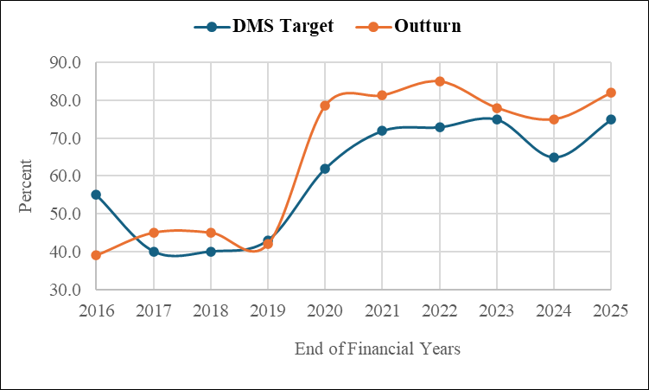
Source: Various MTDSs

- Consistent excess of domestic borrowing above DMS targets in the outer years reflects a deliberate policy pivot away from external borrowing to reduce exchange rate risk. Secondly, tightening global financial conditions from 2021 onward significantly raised the cost of external financing, constraining access to international capital markets. Hence the government shifted towards domestic alternatives. Lastly, the improved depth and liquidity of the domestic debt market over the review period provided a more accessible and reliable financing avenue, facilitating domestic borrowing volumes that consistently exceeded the targets set under earlier debt management strategies.

- The high standard deviation (8.4 percentage points) indicates that deviations in domestic gross borrowing vary significantly over time, driven by a structural shift after 2020 where domestic borrowing consistently exceeded targets and acted as the primary adjustment mechanism to limited financing capacity.

Findings, Conclusions and Policy Recommendations
- Findings: The assessment finds that although Kenya has consistently developed comprehensive and transparent debt management strategies, there are persistent gaps between targets and actual outcomes driven largely by market conditions and implementation constraints.

- Over the period 2015–2025, public debt increased significantly, with a shift toward domestic borrowing reflecting efforts to reduce foreign exchange risk but also highlighting growing reliance on domestic markets. Cost indicators such as interest payments consistently exceeded targets due to rising debt levels, higher domestic borrowing costs, and global financial pressures.

- Additionally, risk indicators reveal mixed performance, with improvements in refinancing risk during certain periods but persistent shortfalls in key metrics such as external ATM, ATR, and fixed rate debt shares due to structural and market constraints. On the other hand, borrowing outcomes show a clear structural shift after 2019, where reduced access to external financing and tighter global conditions led to greater dependence on domestic borrowing, causing deviations from planned targets across several indicators.

- Conclusion: The paper concludes that while Kenya’s debt management strategy framework is sound and well-articulated, its effectiveness is constrained by external market conditions, domestic financing realities, and optimistic assumptions embedded in strategy targets.

- Persistent deviations between targets and outturns indicate that some strategy assumptions particularly regarding borrowing costs, access to concessional financing, and maturity extension were not fully aligned with evolving economic and market conditions. As a result, actual debt outcomes reflect a more constrained and adaptive financing approach, with increased reliance on domestic borrowing and shorter maturities, leading to heightened exposure to refinancing and interest rate risks despite strategic intentions to mitigate them.

- Policy recommendations: The debt management strategies should adopt more realistic and flexible assumptions on interest rates, external financing availability, and market conditions, to improve alignment between targets and outcomes.

- There is a need to strengthen access to concessional and long-term external financing, which would support maturity extension and reduce borrowing costs while limiting reliance on shorter-term commercial debt.

- The government should continue to develop and deepen the domestic debt market, while carefully managing the trade-off between cost and risk to avoid excessive reliance on short-term and high-cost instruments.

- Enhancing risk management through a balanced portfolio composition and increased issuance of longer-term and fixed rate instruments when conditions allow.

- Strengthen implementation monitoring and feedback mechanisms within the PDMO to ensure that strategies are regularly adjusted in response to emerging constraints and financing conditions.

- Lastly, institutionalize detailed annual DMS implementation reviews, as the current annual reports DMS review remains high level. This will allow for deeper analysis to better assess performance and strengthen alignment with the strategy.

Debt excluded in FY 2024/25 amounted to 2.2 percent of public and publicly guaranteed debt.

